MySQL Assignment 2 – DDL Constraints

Que: Create a database called “Sales” and create a new table named “Orders” in the Sales database with columns: (Order_Id, Customer_name, Product_Category, Ordered_item, Contact_No). Use constraints: Primary Key Unique Not Null 1. Add a new column named “order_quantity” to the orders table. 2. Rename the orders table to the sales_orders table. 3. Insert 10 rows into the sales_orders table. 4. Retrieve customer_name and Ordered_Item from the sales_orders table. 5. Use the update command to change the name of the product for any row. 6. Delete the sales_orders table from the database.

Ans:

-- Create a database called “Sales”

-- create database

create database Sales;

use sales;

-- create a new table named “Orders” in the Sales database with columns:

-- (Order_Id, Customer_name, Product_Category, Ordered_item, Contact_No). Use constraints: Primary Key Unique Not Null

create table Orders(

Order_Id INT PRIMARY KEY,

Customer_name varchar(30),

Product_Category varchar(20) not null,

Ordered_item varchar(30),

Contact_No bigint unique

);

desc orders;

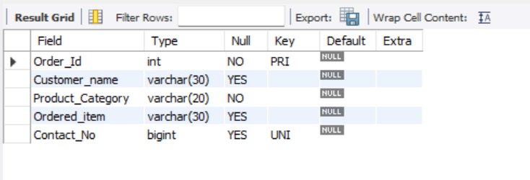

-- 1. Add a new column named “order_quantity” to the orders table.

alter table orders add Order_quantity int;

desc orders;

-- 2. Rename the orders table to the sales_orders table.

rename table orders to Sales_Orders;

desc sales_orders;

-- 3. Insert 10 rows into the sales_orders table.

insert into sales_orders values(6574,'Anandu', 'electronics', 'iron box', 8281365067, 4);

insert into sales_orders values(6382,'Ashok', 'industry', 'spanner', 8281365061, 1);

insert into sales_orders values(9874,'Sobha', 'grocery', 'fruits', 8281365062, 2);

insert into sales_orders values(2367,'Akhil', 'mechanical', 'compass', 8281365063, 3);

insert into sales_orders values(9846,'Abhirami', 'grocery', 'pen', 8281365064, 5);

insert into sales_orders values(6478,'Anaswa', 'grocery', 'vegetables', 8281365065, 6);

insert into sales_orders values(9345,'Akshad', 'toys', 'car', 8281365066, 7);

insert into sales_orders values(6472,'Adishesh', 'toys', 'jeep', 8281365068, 8);

insert into sales_orders values(9485,'Anjali', 'academics', 'table', 8281365069, 9);

insert into sales_orders values(1425,'Aswathy', 'grocery', 'moong seeds', 8281365060, 2);

select * from sales_orders;

-- 4. Retrieve customer_name and Ordered_Item from the sales_orders table.

select customer_name, ordered_item from sales_orders;

-- 5. Use the update command to change the name of the product for any row.

update sales_orders set ordered_item = 'drilling machine' where customer_name = 'ashok';

select * from sales_orders;

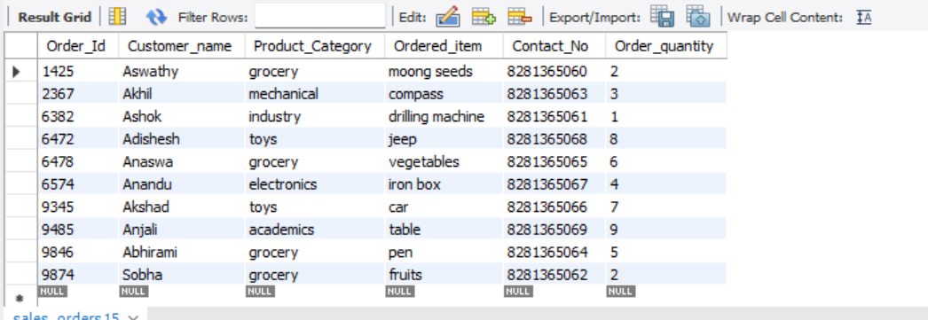

-- 6. Delete the sales_orders table from the database.

drop table sales_orders;